

# HIT137 SOFTWARE NOW

**Assignment No: 03** Submitted By Group No: **SYD 24**

# Group Details –

|  |  |
| --- | --- |
| **Student Name** | **Student ID** |
| MD SAKIBUL ISLAM | S390852 |
| Jasia Binte Alam | S391195 |
| Md Nurul Islam Chowdhury | S390923 |

**Submitted To Reem Sherif** Lecturer

Charles Darwin University

Faculty of Science & Technology, Engineering 30th May 2025

# Answer to the Question Number 01

**A desktop image editor that uses OOP, Tkinter, and OpenCV features**

**1. Library Imports**

python

import tkinter as tk

from tkinter import filedialog, messagebox

from PIL import Image, ImageTk

import cv2

import numpy as np

* tkinter: Python's built-in GUI library for desktop apps.

* filedialog, messagebox: Modules to open file picker and show popups.

* PIL(Python Imaging Library): For loading and handling image files.

* cv2: OpenCV library for image processing.

* numpy: Supports matrix operations, essential for OpenCV.

**2. Class Initialization**

python

class ImageEditorApp:

def __init__(self, root):

* Defines the GUI app as a class. Uses object-oriented programming to encapsulate functions and data.

* root: Main Tkinter window.

python

self.root = root

self.root.title("Image Crop & Resize Editor with Extras")

* Sets window title.

python

self.original_img = None

self.cv_img = None

self.cropped_img = None

self.display_img = None

self.tk_img = None

* Placeholder variables for different image types.

python

self.start_x = self.start_y = 0

self.rect_id = None

self.crop_coords = None

* Coordinates for crop area and drawn rectangle.

python

self.undo_stack = []

self.redo_stack = []

* Lists to implement undo/redo feature.

Python

self.is_grayscale = False

self.is_flipped = False

* Flags to track if image is grayscale or flipped.

python

self.setup_ui()

self.setup_bindings()

* Calls methods to build the UI and set keyboard shortcuts.

**3. UI Setup and Bindings**

* setup_ui(): Adds buttons, canvas, and slider.

* setup_bindings(): Adds Ctrl+S, Ctrl+Z, etc.

**4. Image Loading**

python

def load_image(self):

* Opens file dialog, loads image using PIL.

* Converts to RGB and OpenCV BGR format.

* Resets all flags and UI elements.

**5. Mouse Events (Cropping)**

python

def on_button_press, on_move_press, on_button_release

* Track mouse to draw a rectangle.

* Display real-time crop preview.

**6. Image Display**

python

def display_image(self, pil_img):

* Converts a PIL image to `ImageTk.PhotoImage` and displays on canvas.

**7. Cropping**

python

def crop_image(self):

* Validates selection, applies crop, updates canvas, allows resize.

**8. Resizing**

python

def resize_image(self, val):

* Resizes the cropped image using OpenCV.

* Updates preview and canvas.

**9. Saving**

python

def save_image(self):

* Saves current image to disk.

**10. Undo/Redo**

python

def push_undo, undo, redo

* Tracks image changes and allows reverting.

**11. Grayscale Toggle**

python

def toggle_grayscale(self):

* Converts image to grayscale or restores color.

**12. Flip Horizontal**

python

def flip_horizontal(self):

* Flips image left-right using OpenCV.

**13. Program Entry**

python

if __name__ == "__main__":

* Starts the application by calling ImageEditorApp and mainloop().

**Output:**

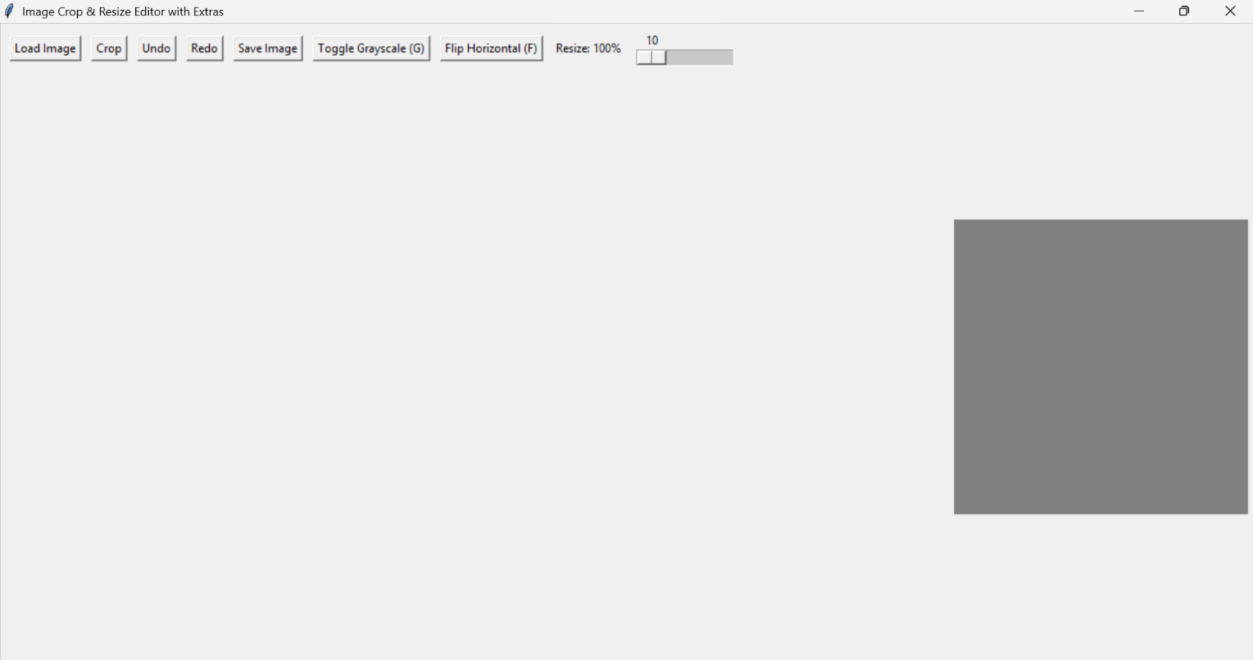

Figure 1: Image editor display bar.

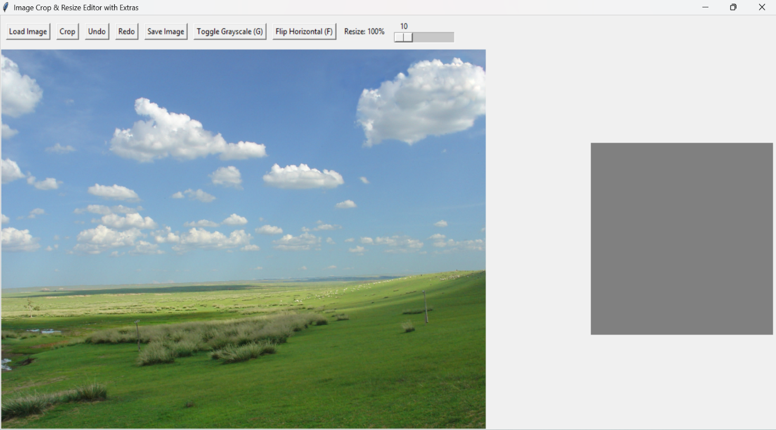

Figure 2: Loading image by Load image function.

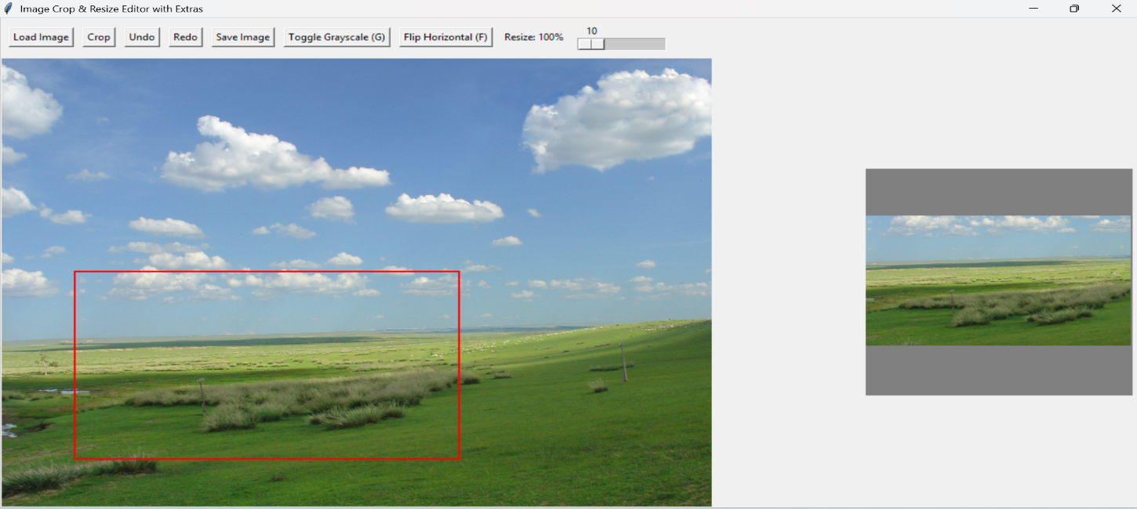

Figure 3: Real time cropping with cropped result.

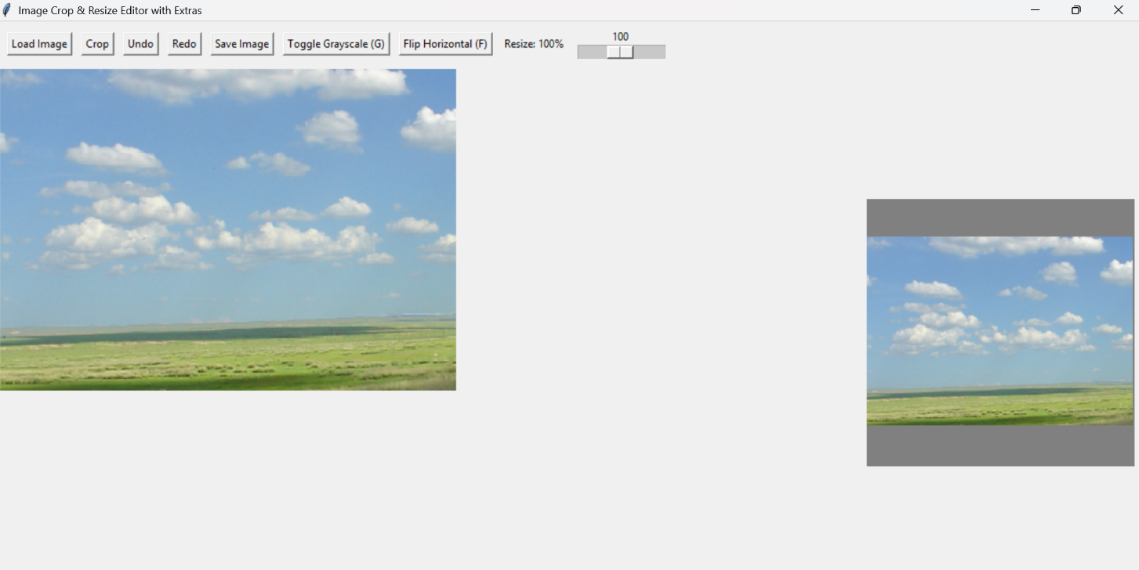

Figure 4: Crop function after cropping.

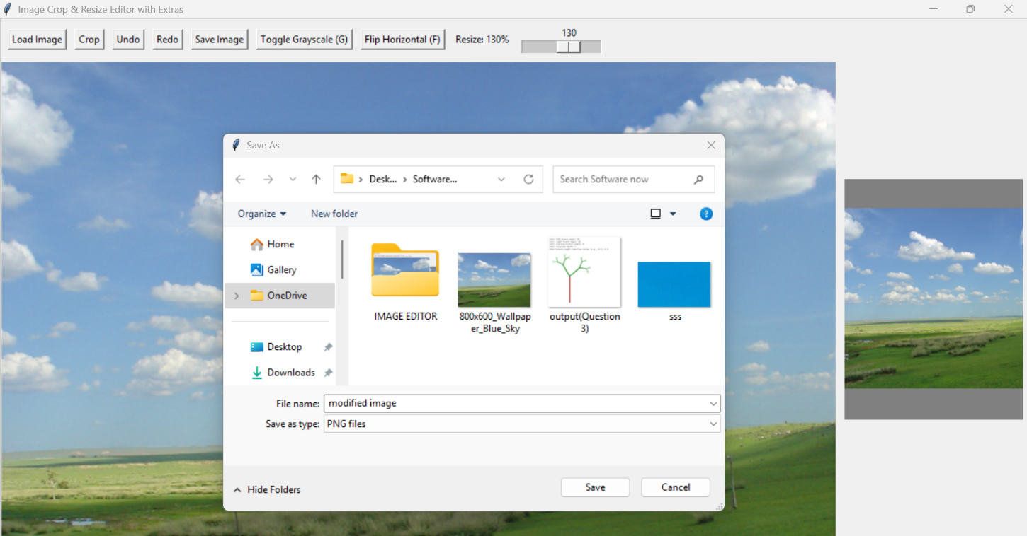

Figure 5: Saving Image after modification.

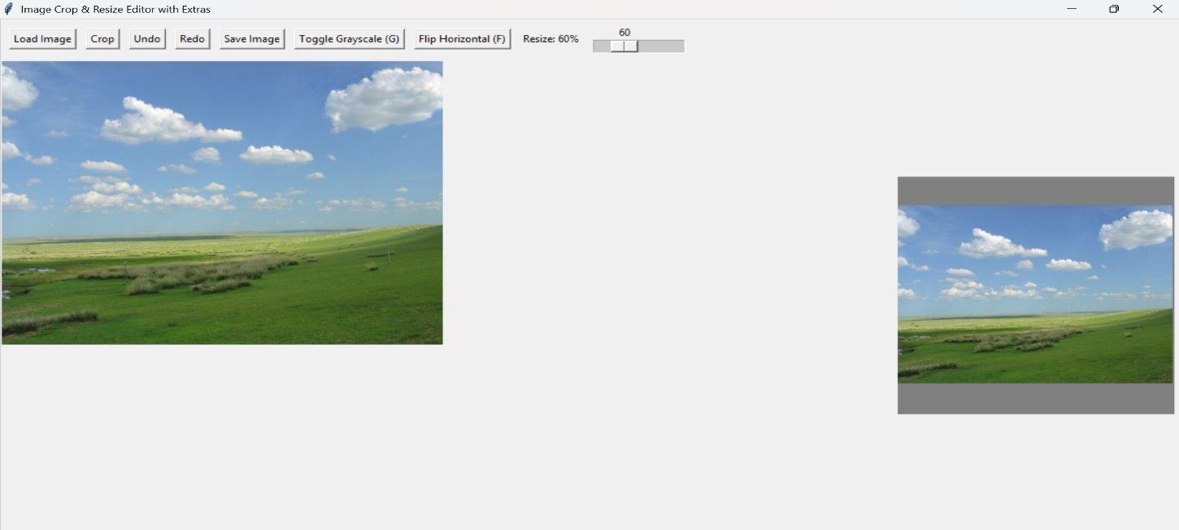

Figure 6: Real time resizing (size=60).

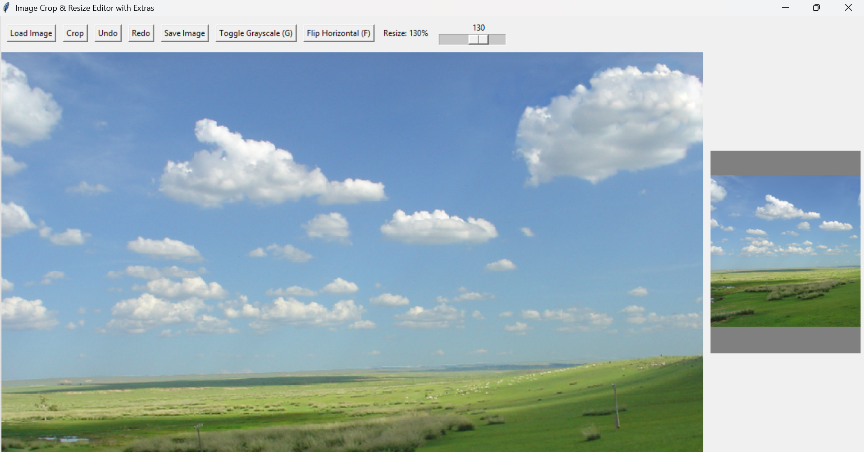

Figure 7: Real time resizing (size=130).

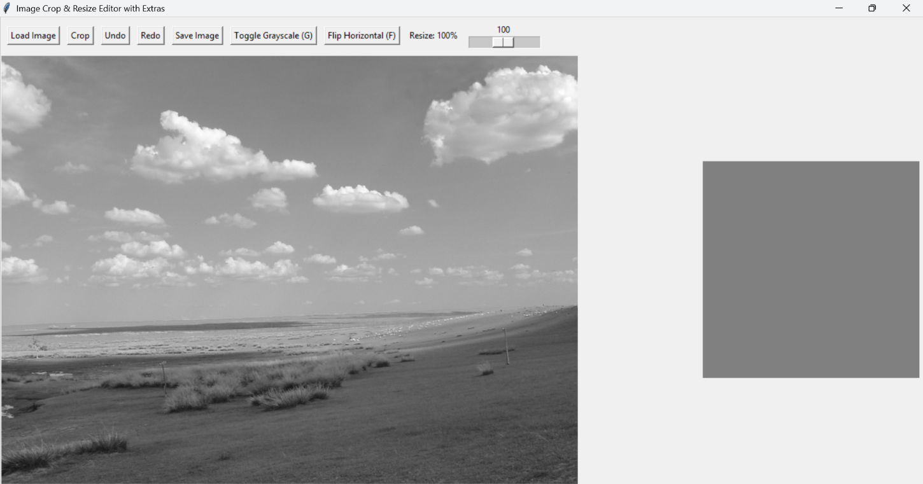

Figure 8: Grayscale feature.

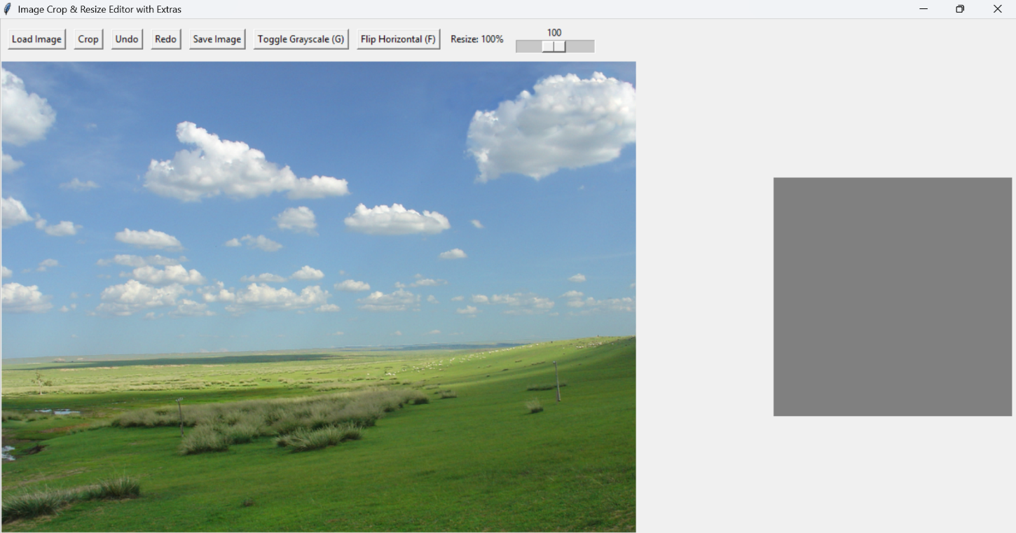

Figure 9: Undo Grayscale feature.

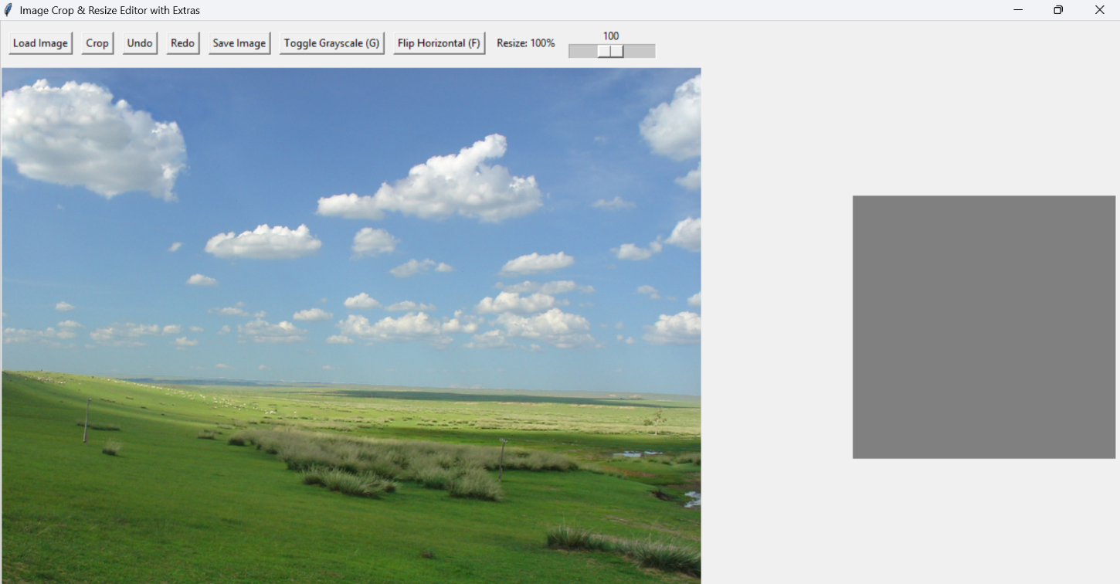

Figure 10: Flip horizontal feature.